|  |  |
| --- | --- |
| Semester | T.E. Semester VI – Computer Engineering |
| Subject | Cloud Computing |
| Subject Professor In-charge | Prof. Divya Nimbalkar |
| Assisting Teachers | Prof. Divya Nimbalkar |

|  |  |
| --- | --- |
| Student Name | Deep Salunkhe |
| Roll Number | 21102A0014 |
| TE Division | A |

**Title:  Docker and** **Kubernestes**



**Implementation:**

**Docker:**

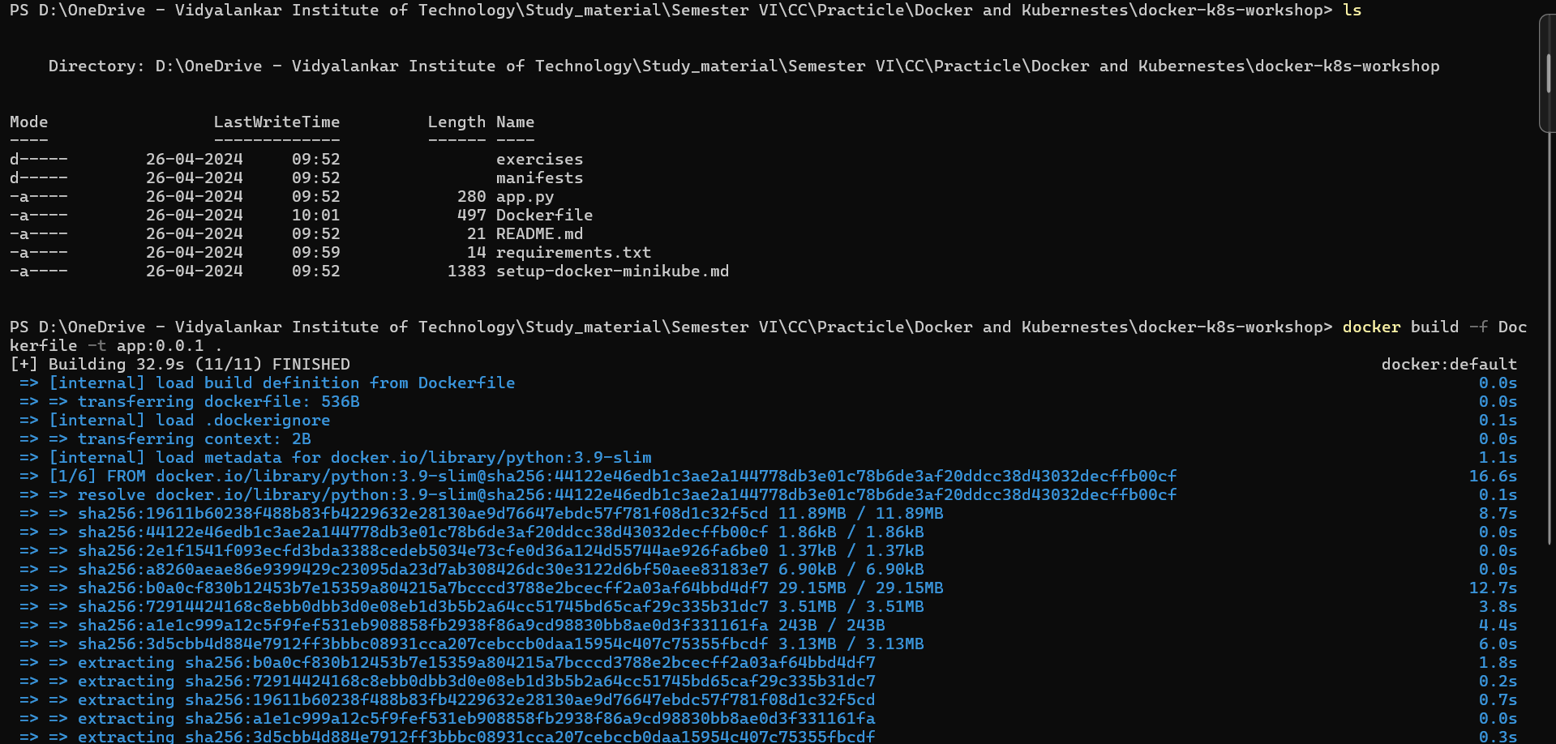

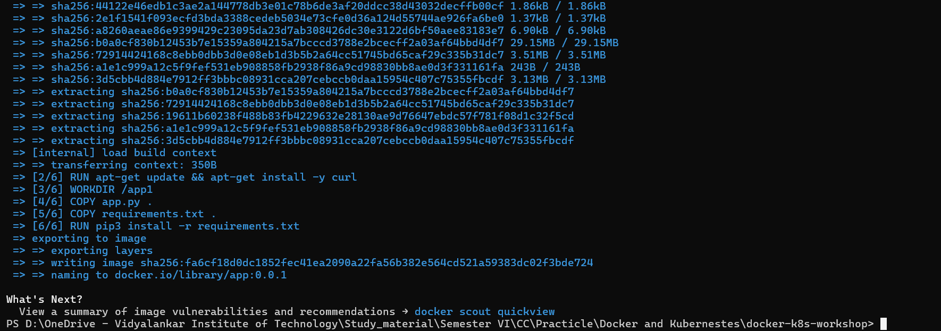

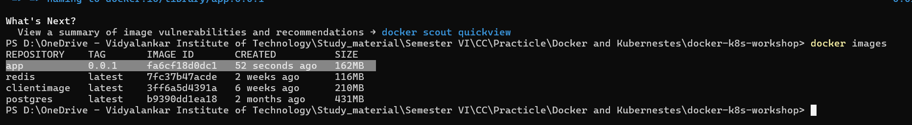

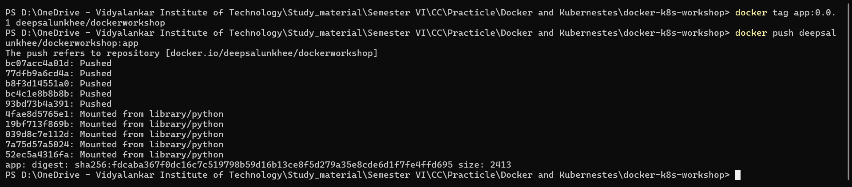

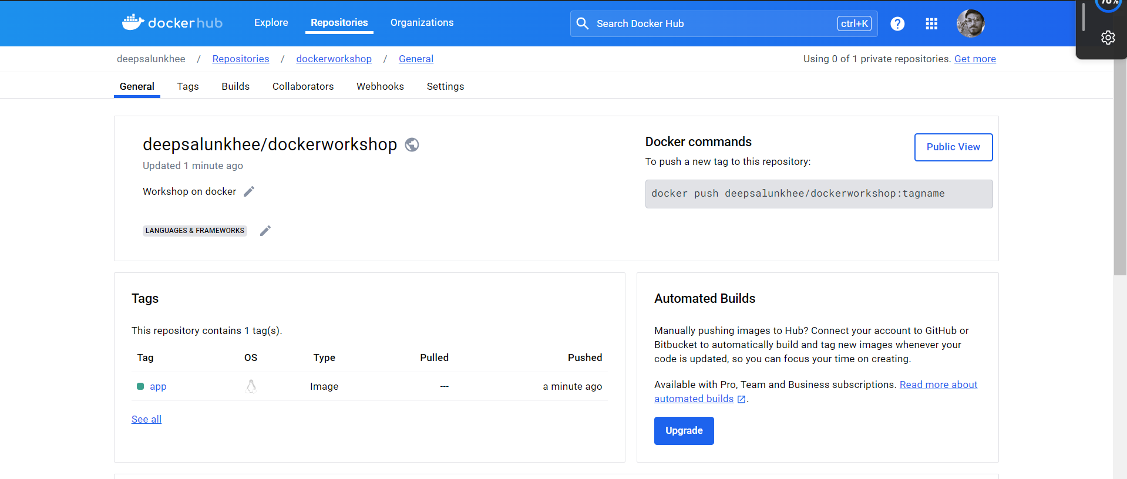

**Kubernestes**





